**Tutorial 9**

**SQL statement**

Use interactive editor on the website to complete the tasks below. https://www.sqlcourse.com/beginner-course/selecting-data/

table name is :empinfo

**Part I**  
Solutions are also available on the website. Select statement exercises Enter select statements to:  
 1. Display the first name and age for everyone that's in the table.

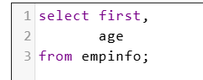

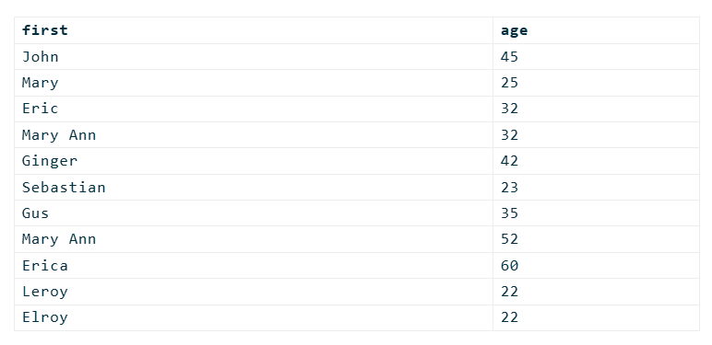  
2. Display the first name, last name, and city for everyone that's not from Payson

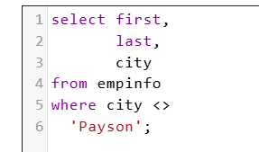

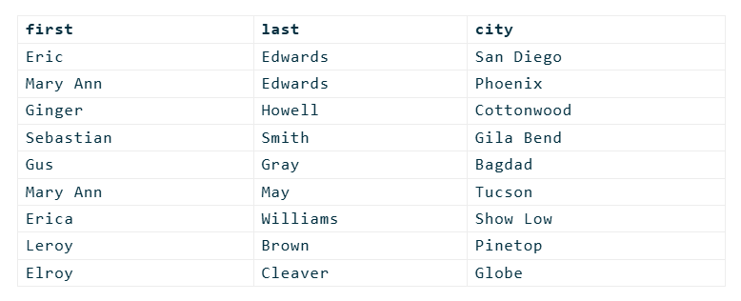  
. 3. Display all columns for everyone that is over 40 years old.

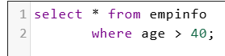

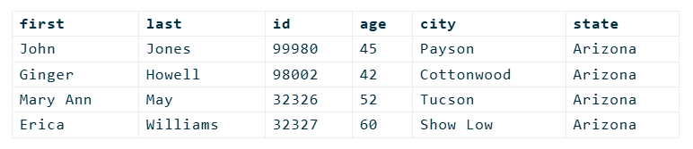  
 4. Display the first and last names for everyone whose last name ends in an "ay".

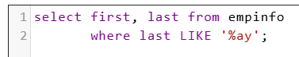

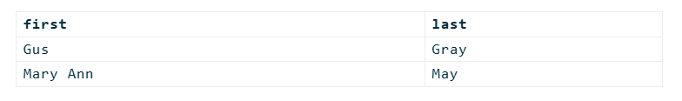  
5. Display all columns for everyone whose first name equals "Mary".

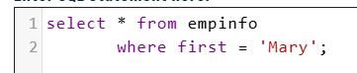

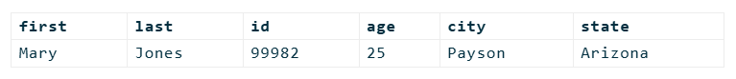

 6. Display all columns for everyone whose first name contains "Mary".

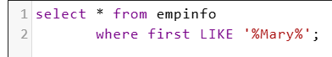

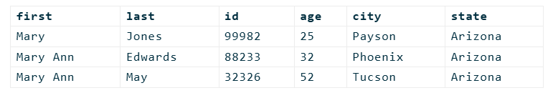  
**PART II**  
  
 Update statement exercises After each update, issue a select statement to verify your changes.  
editor link <http://www.sqlcourse.com/update.html>    **(incase your query is not supported by the editor you only need to type the SQL statements)  
Table name:  myemployees  
columns are as follow firstname, lastname, age, salary and title**  
 1. Jonie Weber just got married to Bob Williams. She has requested that her last name be updated to Weber-Williams.

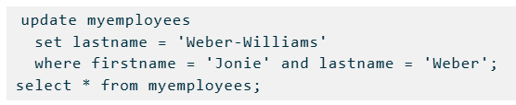  
 2. Dirk Smith's birthday is today, add 1 to his age.

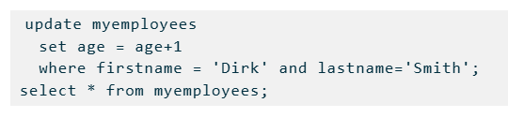

 3. All secretaries are now called "Administrative Assistant". Update all titles accordingly.

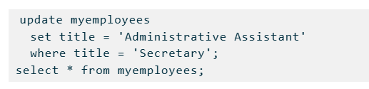  
 4. Everyone that's making under 30000 are to receive a 3500 a year raise.

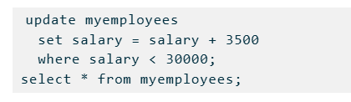  
5. Everyone that's making over 33500 are to receive a 4500 a year raise.

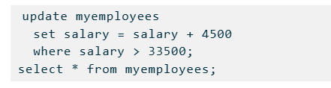  
6. All "Programmer II" titles are now promoted to "Programmer III".

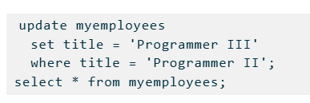  
7. All "Programmer" titles are now promoted to "Programmer II".

